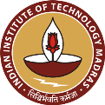
Sophisticated Analytical Instrument Facility (SAIF)
Indian Institute of Technology Madras (IITM), Chennai 600036

National Workshop on “Theory and Applications of Single Crystal X-ray Diffraction”
Nov 08-10, 2017

REGISTRATION FORM

Name :

Email Address :

Mobile Number :

DD No: DD Amount: Date: Bank:

Designation :

Affiliation :

Company / Institute Address :

Purpose for Attending Workshop:

Signature of the Research Supervisor Seal Signature of the Applicant

Date:

